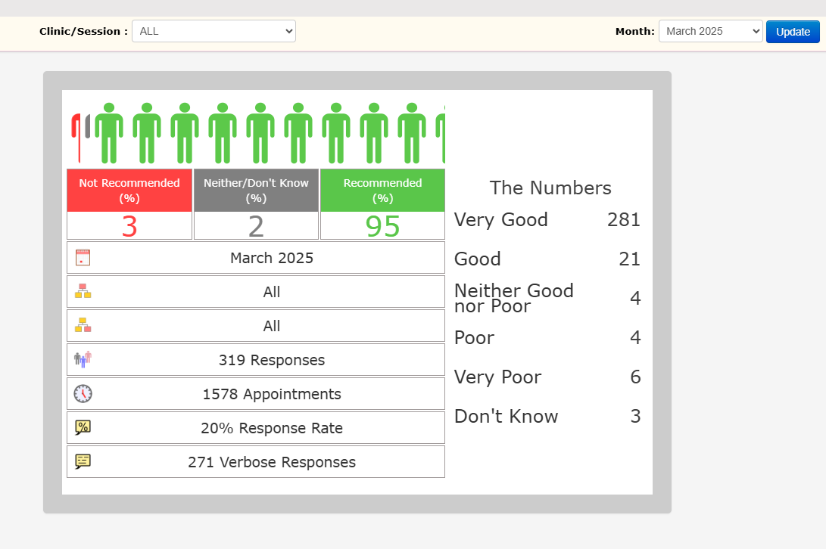**Friends and Family – March 2025 Totals**